Manav Rachna university

DBMS project

Hotel management system

BY

Amareswara Reddy Venna (1119)

Nagarjuna Reddy Tanubuddi (1117)

Anand Prakash (1068)

CREATE

create database HOT_MAG_SYS;

Query OK, 1 row affected (0.005 sec)

MariaDB [(none)]> use hot_mag_sys;

Database changed

MariaDB [hot_mag_sys]> create table guests(phone int(10),address varchar(255),login_id int(4),password varchar(20),fname varchar(255),lname varchar(255),email varchar(255));

Query OK, 0 rows affected (0.042 sec)

MariaDB [hot_mag_sys]> create table rooms(number int(10),level int(10),style varchar(10),view varchar(10),beds varchar(10),smoking varchar(10));

Query OK, 0 rows affected (0.038 sec)

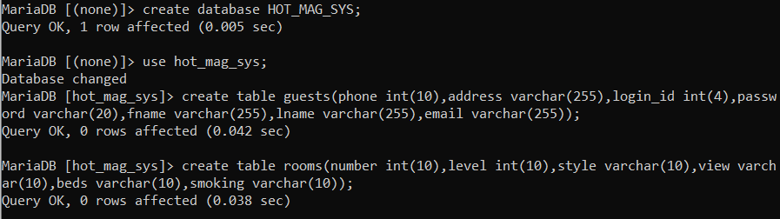

create table reservations(checkout date,checkin date,res_no int(10));

Query OK, 0 rows affected (0.040 sec)



**INSERT**

insert into reservations(checkout,checkin,res_no)

-> values

-> ('2020-04-12','2020-04-09',12321),

-> ('2020-03-12','2020-03-08',1653),

-> ('2020-03-19','2020-02-07',1453),

-> ('2020-03-11','2020-01-01',7645);

Query OK, 4 rows affected (0.011 sec)

Records: 4 Duplicates: 0 Warnings: 0

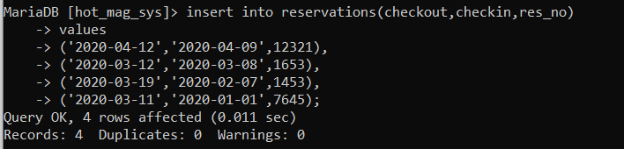

MariaDB [hot_mag_sys]> desc rooms;

+---------+-------------+------+-----+---------+-------+

| Field | Type | Null | Key | Default | Extra |

+---------+-------------+------+-----+---------+-------+

| number | int(10) | YES | | NULL | |

| level | int(10) | YES | | NULL | |

| style | varchar(10) | YES | | NULL | |

| view | varchar(10) | YES | | NULL | |

| beds | varchar(10) | YES | | NULL | |

| smoking | varchar(10) | YES | | NULL | |

+---------+-------------+------+-----+---------+-------+

6 rows in set (0.041 sec)

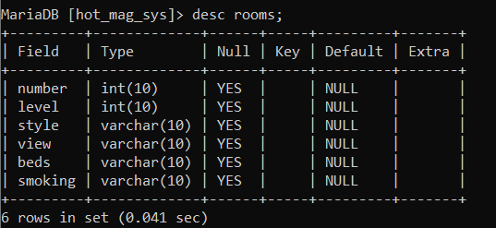

insert into rooms(number,level,style,view,beds,smoking)

-> values

-> (12,6,'couple','pool',1,'allowed'),

-> (23,9,'couple','balcony',1,'allowed'),

-> (13,9,'family','normal',1,'allowed'),

-> (8,12,'family','kids',3,'not_allowed');

Query OK, 4 rows affected, 1 warning (0.013 sec)

Records: 4 Duplicates: 0 Warnings: 1

MariaDB [hot_mag_sys]> desc guests;

+----------+--------------+------+-----+---------+-------+

| Field | Type | Null | Key | Default | Extra |

+----------+--------------+------+-----+---------+-------+

| phone | int(10) | YES | | NULL | |

| address | varchar(255) | YES | | NULL | |

| login_id | int(4) | YES | | NULL | |

| password | varchar(20) | YES | | NULL | |

| fname | varchar(255) | YES | | NULL | |

| lname | varchar(255) | YES | | NULL | |

| email | varchar(255) | YES | | NULL | |

+----------+--------------+------+-----+---------+-------+

7 rows in set (0.037 sec)

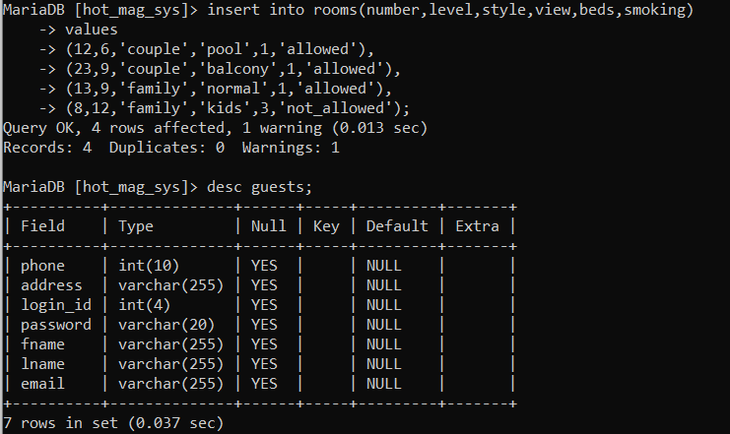

insert into guests(phone,address,login_id,password,fname,lname,email)

-> values

-> (13132423,'tam_nadu',121,'e3der3','amar','readdy','amar.com'),

-> (13133242,'delhi',134,'e32tf2','anand',null,'anand.com'),

-> (18745642,'chennei',135,'e32862','nag',null,'nag.com');

Query OK, 3 rows affected (0.010 sec)

Records: 3 Duplicates: 0 Warnings: 0

MariaDB [hot_mag_sys]> select * from guests;

+----------+----------+----------+----------+-------+--------+-----------+

| phone | address | login_id | password | fname | lname | email |

+----------+----------+----------+----------+-------+--------+-----------+

| 13132423 | tam_nadu | 121 | e3der3 | amar | readdy | amar.com |

| 13133242 | delhi | 134 | e32tf2 | anand | NULL | anand.com |

| 18745642 | chennei | 135 | e32862 | nag | NULL | nag.com |

+----------+----------+----------+----------+-------+--------+-----------+

3 rows in set (0.000 sec)

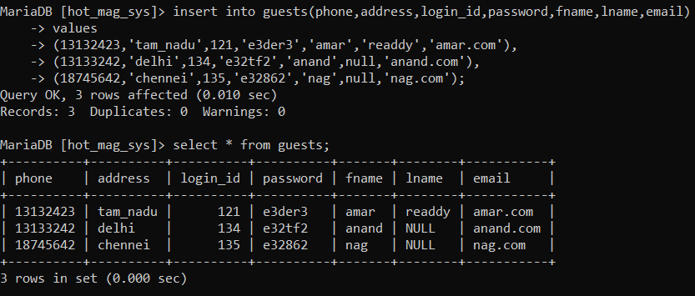

MariaDB [hot_mag_sys]> select * from reservations;

+------------+------------+--------+

| checkout | checkin | res_no |

+------------+------------+--------+

| 2020-04-12 | 2020-04-09 | 12321 |

| 2020-03-12 | 2020-03-08 | 1653 |

| 2020-03-19 | 2020-02-07 | 1453 |

| 2020-03-11 | 2020-01-01 | 7645 |

+------------+------------+--------+

4 rows in set (0.000 sec)

MariaDB [hot_mag_sys]> select * from rooms;

+--------+-------+--------+---------+------+------------+

| number | level | style | view | beds | smoking |

+--------+-------+--------+---------+------+------------+

| 12 | 6 | couple | pool | 1 | allowed |

| 23 | 9 | couple | balcony | 1 | allowed |

| 13 | 9 | family | normal | 1 | allowed |

| 8 | 12 | family | kids | 3 | not_allowe |

+--------+-------+--------+---------+------+------------+

4 rows in set (0.000 sec)

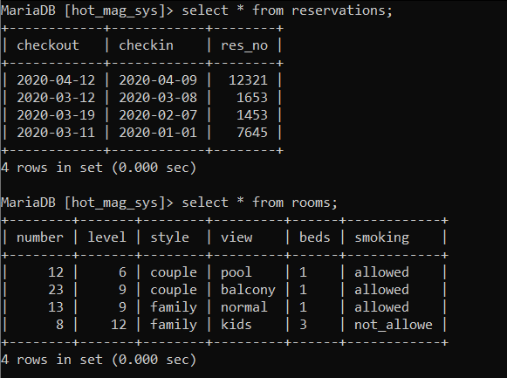

**UPDATE**

update rooms

-> set style ='couple'

-> where level=9;

Query OK, 1 row affected (0.010 sec)

Rows matched: 2 Changed: 1 Warnings: 0

MariaDB [hot_mag_sys]> select * from rooms;

+--------+-------+--------+---------+------+------------+

| number | level | style | view | beds | smoking |

+--------+-------+--------+---------+------+------------+

| 12 | 6 | couple | pool | 1 | allowed |

| 23 | 9 | couple | balcony | 1 | allowed |

| 13 | 9 | couple | normal | 1 | allowed |

| 8 | 12 | family | kids | 3 | not_allowe |

+--------+-------+--------+---------+------+------------+

4 rows in set (0.000 sec)

MariaDB [hot_mag_sys]> update reservations

-> set res_no=567

-> where res_no = 1453;

Query OK, 1 row affected (0.010 sec)

Rows matched: 1 Changed: 1 Warnings: 0

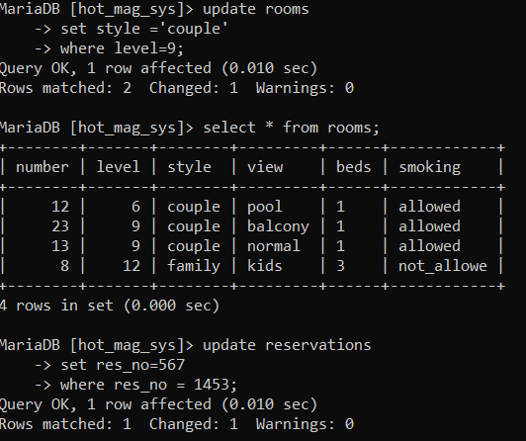

ariaDB [hot_mag_sys]> update reservations

-> set res_no=567

-> where res_no = 1453;

Query OK, 1 row affected (0.010 sec)

Rows matched: 1 Changed: 1 Warnings: 0

MariaDB [hot_mag_sys]> select * from reservations;

+------------+------------+--------+

| checkout | checkin | res_no |

+------------+------------+--------+

| 2020-04-12 | 2020-04-09 | 12321 |

| 2020-03-12 | 2020-03-08 | 1653 |

| 2020-03-19 | 2020-02-07 | 567 |

| 2020-03-11 | 2020-01-01 | 7645 |

+------------+------------+--------+

4 rows in set (0.000 sec)

